**Sumit Tamrakar**

**ICT 4370 – Python Programming**

**Assignment 9 – Display Stock Data on the Website (Extra-credit)**

**First, creating a virtual environment, activating and installing Django:**



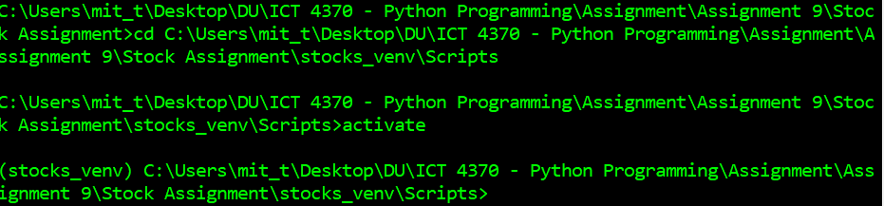

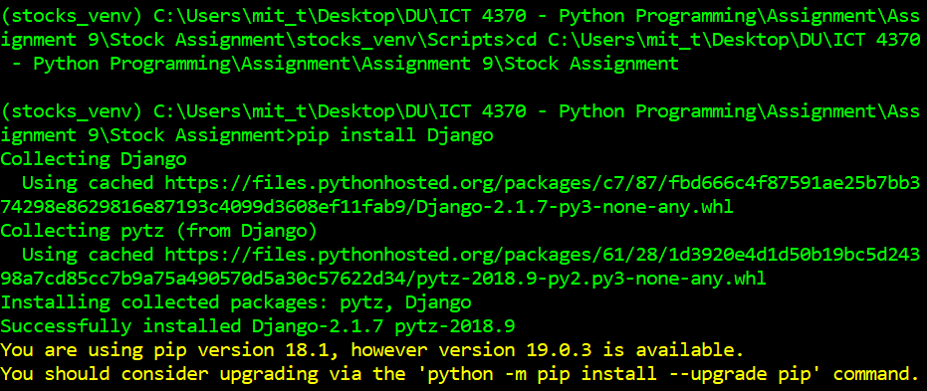

**Creating a new project:**



**Confirming the file structure in the project folder:**

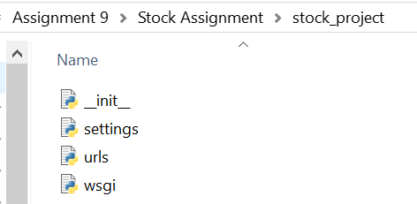

**Next, the changes were made to settings.py for path and name of the database. Running python manage.py migrate:**

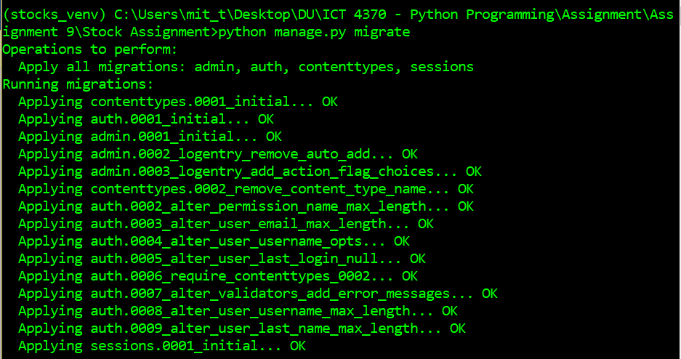

**Generating the model from the database:  
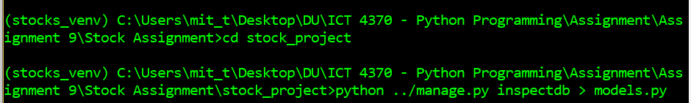**

**The models.py file was opened and ‘blank=True, null=True’ artifacts were removed from Dog and Owner classes. Next, the project was started using following command:**

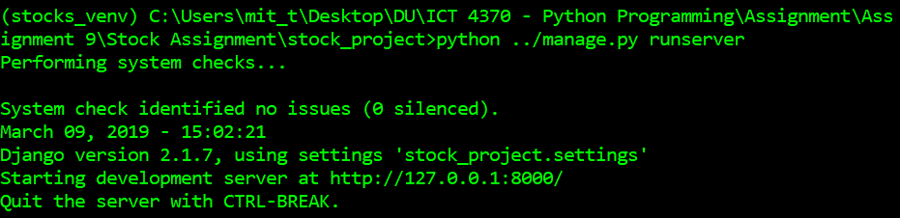

**Copying the development server url** [**http://127.0.0.1:8000/**](http://127.0.0.1:8000/) **into a browser, I got the initial Django app page as below:**

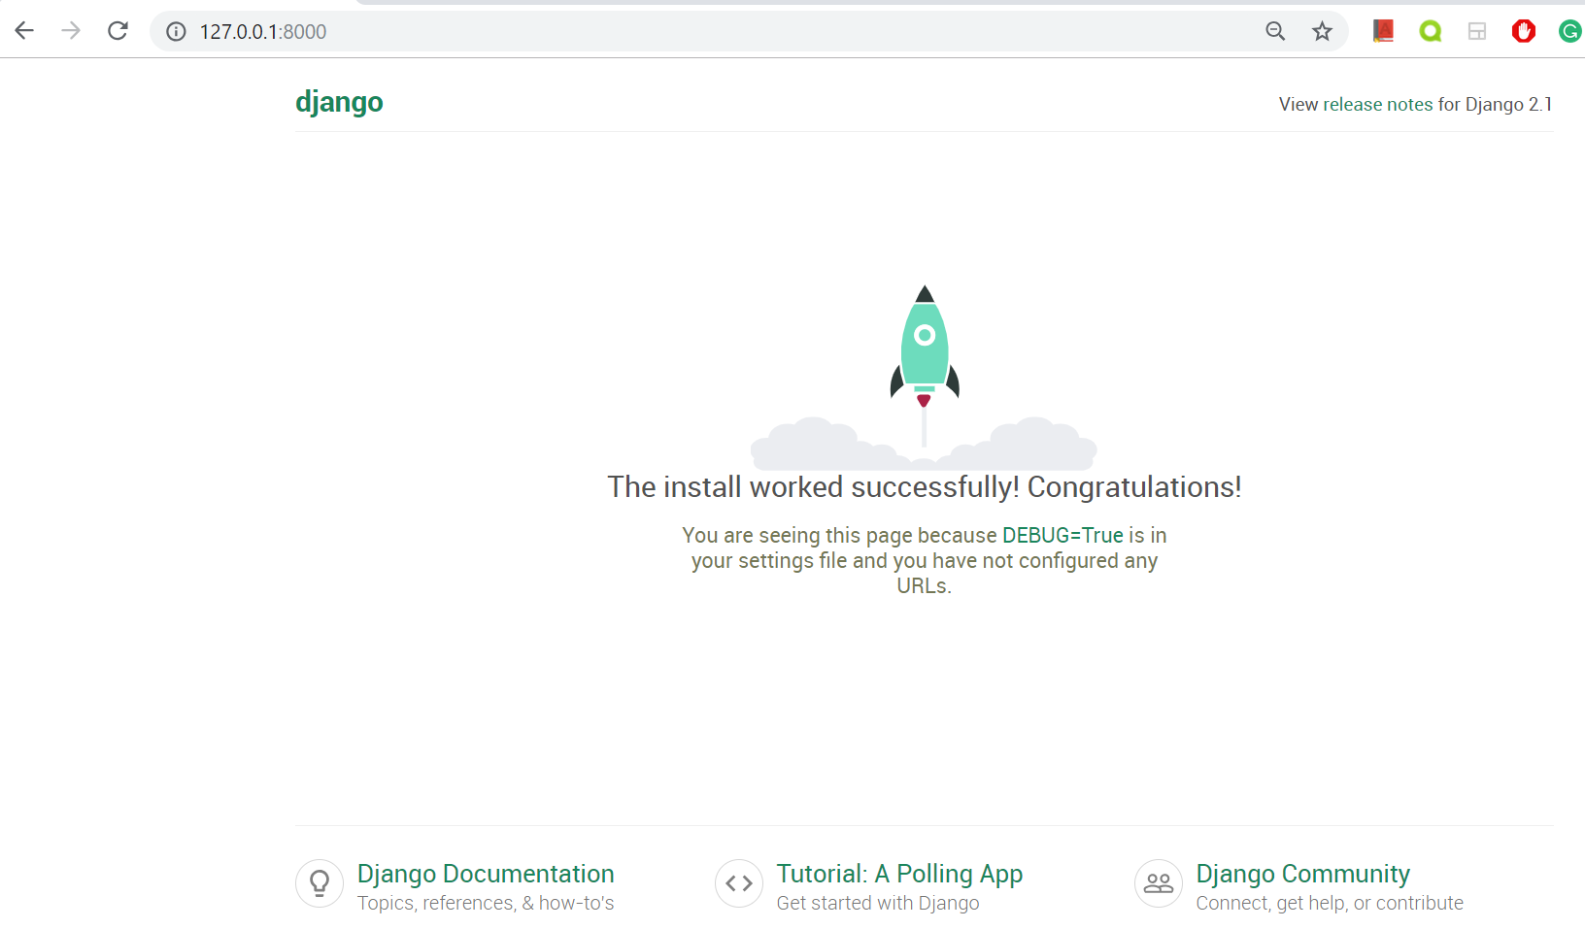

**On a new command prompt window, navigating to the working folder and activating:**

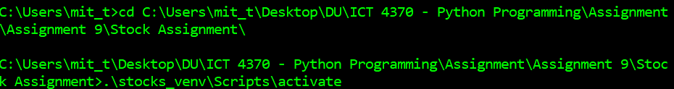

**Creating the app by using the command:**



**Adding ‘stocks_project’ app in the settings.py in the project folder (stock_project):**

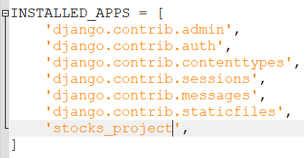

**Next, using makemigrations to create authentication tables:**

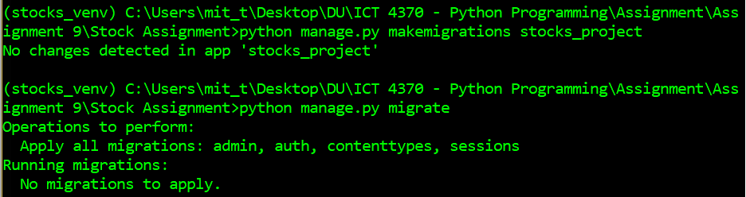

**Checking the database to see the additional tables for authentication:**

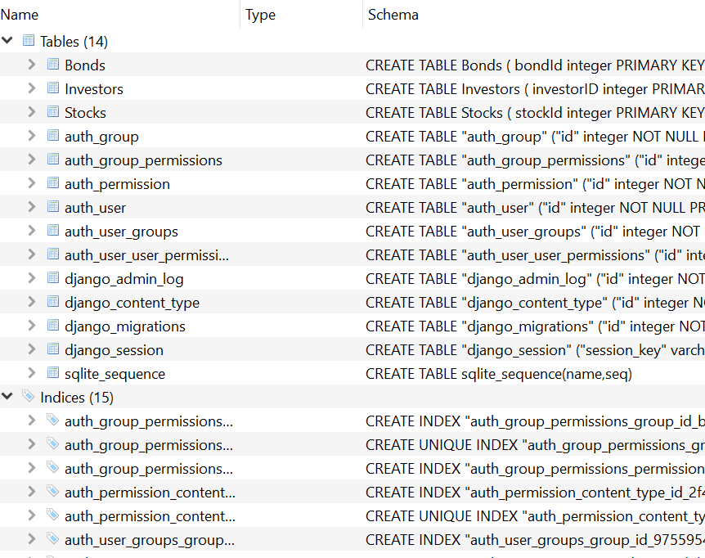

**Creating a super user with username: sumit, password: sumit**

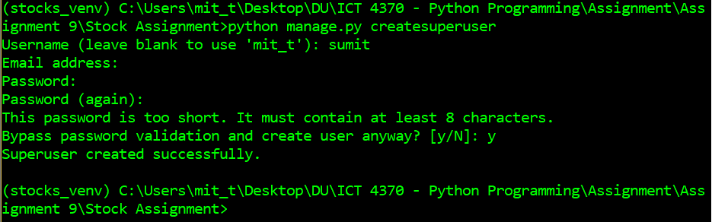

**Checking the admin site** [**http://127.0.0.1:8000/admin/**](http://127.0.0.1:8000/admin/) **for changes made in authentication credentials:**

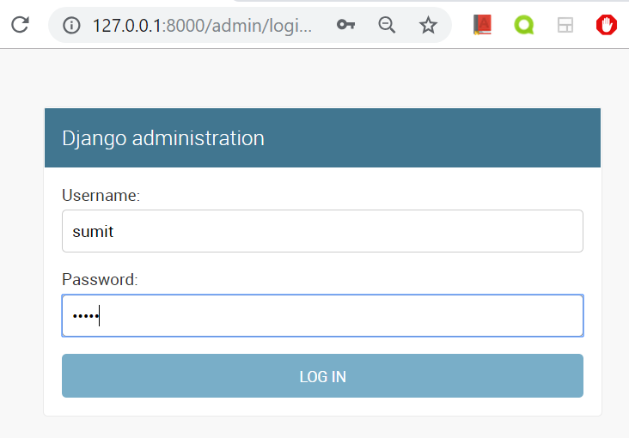

**After logging in with credentials I got Django admin page:**

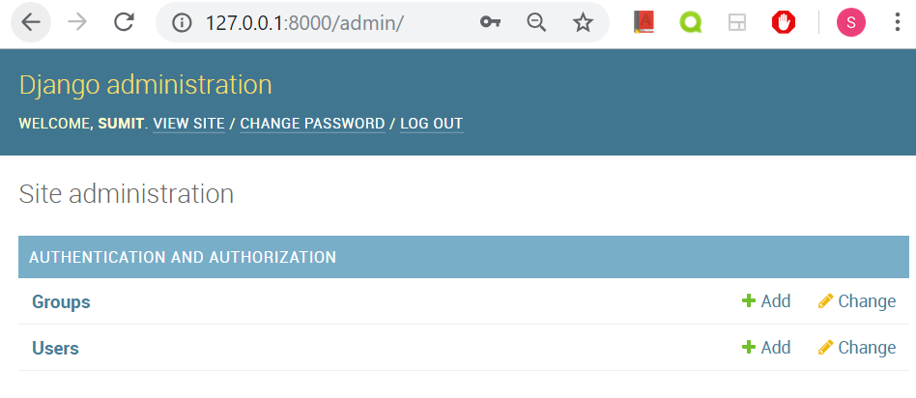

**Next, models.py file was copied to the app folder stocks_project. The admin.py file was opened and below code was added to register the models:**

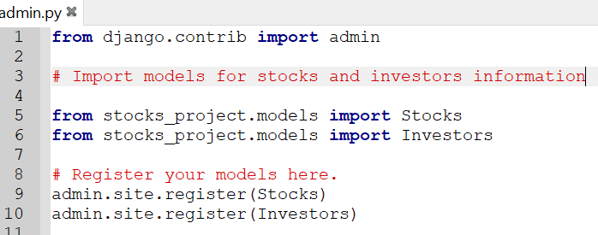

**Checking the admin site, we can see the database records and database tables for Investors and Stocks:**

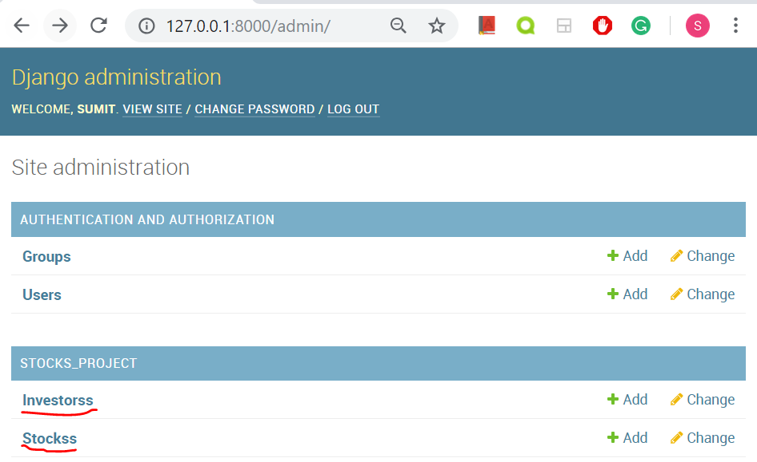

**Checking the same data from the Django console:**

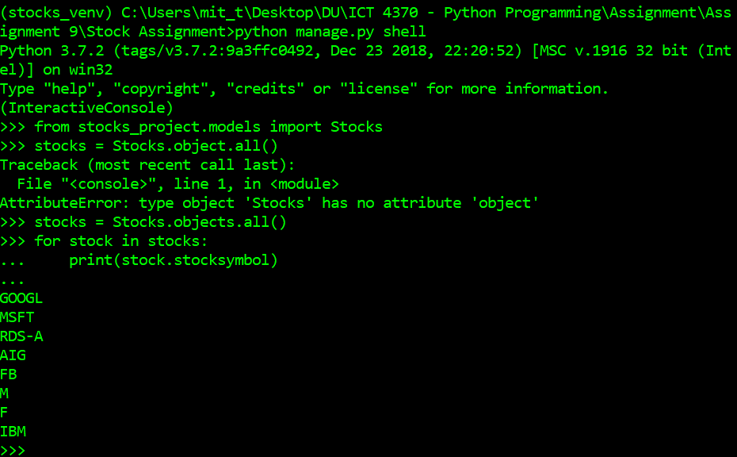

**In the stock_project (project folder), added url code to the urls.py file. In this step, I added ‘conf’ in the import statement:**

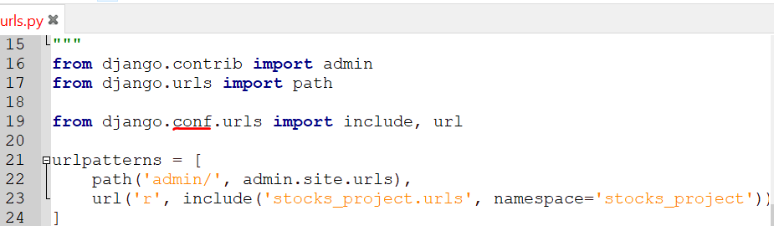

**Next, creating urls.py file on the app folder, stocks_project folder:**

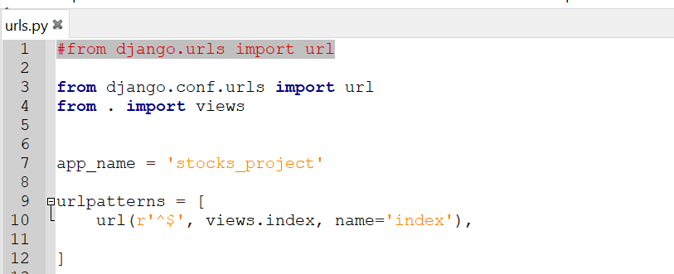

**Added render request files location in the app folder, stocks_projec and creating index.html with following content to check html file is being served correctly:**

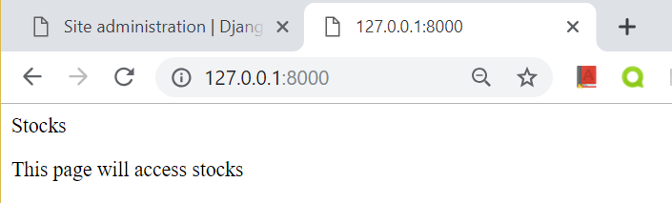

**Next, in the app folder (stocks_project), in the views.py file, I added calls objects from Investors and Stocks database to render function:**

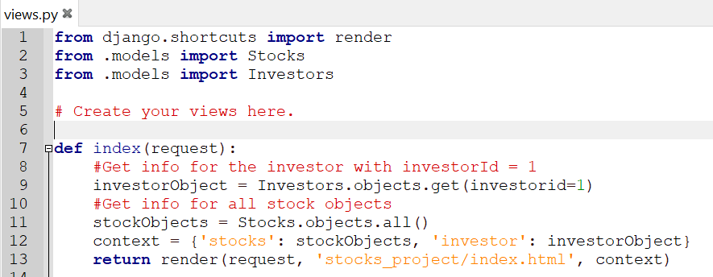

**Then, I created index.html in the template folder with stock information as below:**

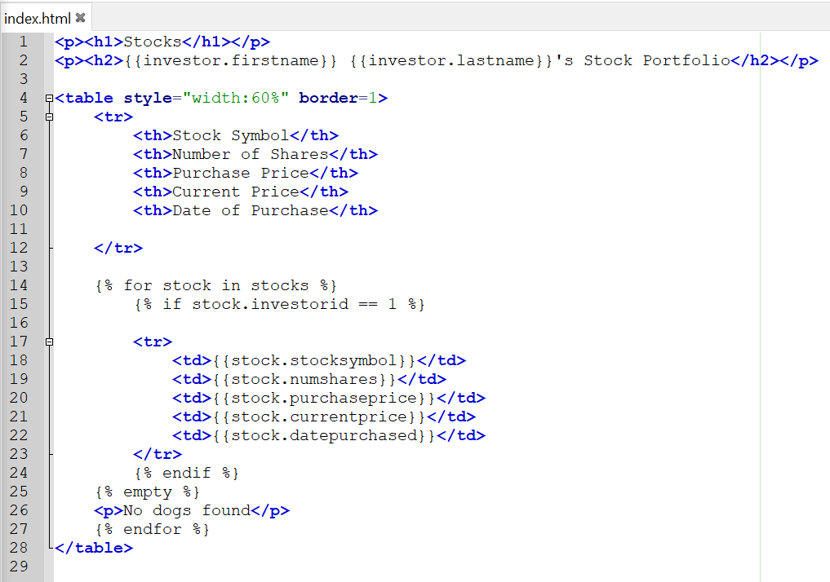

**Finally, starting the web server again I see the web app with investor information that I had asked and stock information in a web app:**

